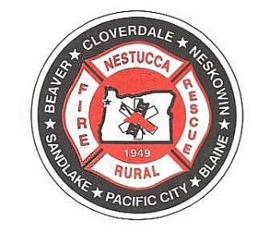
NESTUCCA RURAL FIRE PROTECTION DISTRICT

Board of Directors Budget Hearing Agenda
May 14th, 2025
Station 87 Hebo, Oregon

Turn off all cell phones

All Please Stand for the Pledge of Allegiance

Called to Order Time: _________

Roll Call: Dorothy Gann _____ Steve Shiels ____ Shelley Cully ____
Mark Menefee _____ Anne Price_____

Community Present:

Audience Participation: Three (3) minute time limit

Adjustments to Agenda:

Approval of Minutes: Fiscal Year 2025-2026 Budget Committee Meeting Minutes

Motion to Approve: ____________________ 2nd_________________________
Motion Passed by: Dorothy Gann _____ Steve Shiels ____ Shelley Cully ____
Mark Menefee _____ Anne Price_____

Adjourn:
Motion to Adjourn: ____________________ 2nd_________________________
Motion Passed by: Dorothy Gann _____ Steve Shiels ____ Shelley Cully ____
Mark Menefee _____ Anne Price_____

Time:

